Software Requirements Specification

For

Android Smart Health Prediction Application

**Version 1.0 approved**

**Prepared by**

**Shaikh Humairaa**

**Shaikh Mehvish**

**Zunzunia Arsil**

**MHSSCOE**

**2nd February 2020**

**Table of Contents**

**Table of Contents Error! Bookmark not defined.**

**Revision History** 2

**1. Introduction Error! Bookmark not defined.**

1.1 Purpose **Error! Bookmark not defined.**

1.2 Document Conventions **Error! Bookmark not defined.**

1.3 Intended Audience and Reading Suggestions **Error! Bookmark not defined.**

1.4 Product Scope **Error! Bookmark not defined.**

1.5 References **Error! Bookmark not defined.**

**2. Overall Description Error! Bookmark not defined.**

2.1 Product Perspective **Error! Bookmark not defined.**

2.2 Product Functions **Error! Bookmark not defined.**

2.3 User Classes and Characteristics **Error! Bookmark not defined.**

2.4 Operating Environment **Error! Bookmark not defined.**

2.5 Design and Implementation Constraints **Error! Bookmark not defined.**

2.6 User Documentation **Error! Bookmark not defined.**

2.7 Assumptions and Dependencies **Error! Bookmark not defined.**

**3. External Interface Requirements Error! Bookmark not defined.**

3.1 User Interfaces 3

3.2 Hardware Interfaces **Error! Bookmark not defined.**

3.3 Software Interfaces **Error! Bookmark not defined.**

3.4 Communications Interfaces **Error! Bookmark not defined.**

**4. System Features Error! Bookmark not defined.**

4.1 System Feature 1 **Error! Bookmark not defined.**

4.2 System Feature 2 (and so on) **Error! Bookmark not defined.**

**5. Other Nonfunctional Requirements Error! Bookmark not defined.**

5.1 Performance Requirements 8

5.2 Safety Requirements **Error! Bookmark not defined.**

5.3 Security Requirements **Error! Bookmark not defined.**

5.4 Software Quality Attributes **Error! Bookmark not defined.**

5.5 Business Rules **Error! Bookmark not defined.**

# Introduction

This section gives the scope and overview of everything included in this SRS document. Also, the purpose for this document is described.

## Purpose

## The Health Prediction web application is the patient (end user) support and online consultation project. Here the proposed web application allows users to get instant guidance on their health issues through an intelligent health care application online. The application allows patients to share their symptoms and issues and based on the input provided the system generates a result providing the information about the disease along with suggestions and precautions.

## Document Conventions

The document is written in IEEE format with standard conventions.

## Intended Audience and Reading Suggestions

Various patients who are in urgency of consultant, doctors or software developers who wish to develop such applications for their patients in order to keep records online, Analyst who wish to do analysis on the diseases, faculties of educational institution.

## Product Scope

It might have happened so many times that you or someone yours need doctors help immediately, but they are not available due to some reason. The Health Prediction web application is the patient (end user) support and online consultation project. Here we propose a web application that allows patients to get instant guidance on their health issues through an intelligent health care application online. The application is fed with various symptoms and the disease/illness associated with those systems. The application allows patients to share their symptoms and issues. It then processes patient’s symptoms to check for various illness that could be associated with it. Here we use some intelligent data mining techniques to guess the most accurate illness that could be associated with patient’s symptoms. If the application is not able to provide suitable results, it urges patients to go for blood test, x-ray, CITI scan or whichever report it feels user’s symptoms are associated with, so next time user may be able to login and upload an image of those reports. The application will also provide the details of the respective doctor such as address, contact number and so on for the patient’s to consult in emergency.

## References

* http://ieeexplore.ieee.org/xpl/articleDetails.jsp?arnumber=7192877&queryText=android%20health&ranges=2015_2016_Year
* http://ieeexplore.ieee.org/xpl/articleDetails.jsp?arnumber=7173334&queryText=android%20health&ranges=2015_2016_Year

# Overall Description

This section will give an overview of the whole system. The system will be explained in its context to show how the system interacts with other systems and introduce its basic functionality. It will also describe what type of stakeholders will use the system and what functionality is available for each type. Constraints and assumptions will also be presented.

## Product Perspective

This web application can be used by all patients or their family members who need help in emergency.

## Product Functions

* Login/Logout: The patients and Admin will have to login and logout for to ensure security of data shared.
* Role Based Access of each user :
* Admin can add new doctors and diseases.
* Admins can view doctor details, patient details, disease details
* Admins can also view the feedbacks from users.
* Users / Patients can register themselves for easy access, view their personal details (profile).
* Users / Patients can specify the symptoms to predict the disease.
* Patients can also search the respective doctors by their category, address or name and give their feedbacks.
* On the basis of symptoms entered by the patient, the disease will be predicted and will be displayed to the patient along with relevant doctor details.

## User Classes and Characteristics

There are two user classes: Patients and Admins.

* The Patients are the primary users of this web application and need to be accustomed to an internet connection.
* The verified doctors will be added to the application by Admin.
* The patient’s symptoms will direct him/her to the relevant disease and doctor.
* Technical expertise is not necessary.
* Admin may be the creator of the application or any higher authority in health department who is handling the application.

## Operating Environment

* The web application will work on mobile OS with android version (4.0 and above).
* Internet connection is mandatory.

## Design and Implementation Constraints

The web application must be secure enough as patients personal details will be entered. Also, the application will be used by several users, so there should not be any problem related to multiple access at the same time. Consistency and other security parameters must be ensured.

## User Documentation

There will be options of Contact Us and About Us to assist users.

## Assumptions and Dependencies

Use of third-party application, Mail chimp for mailing.

# External Interface Requirements

This section provides a detailed description of all inputs into and outputs from the system. It also gives a description of the hardware, software and communication interfaces and provides basic prototypes of the user interface.

## User Interfaces

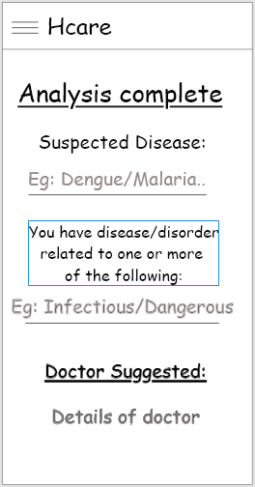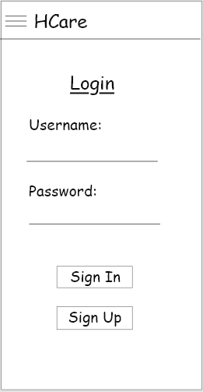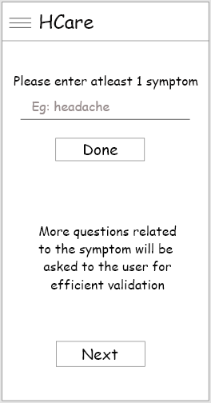

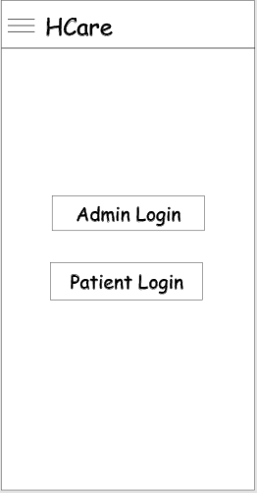

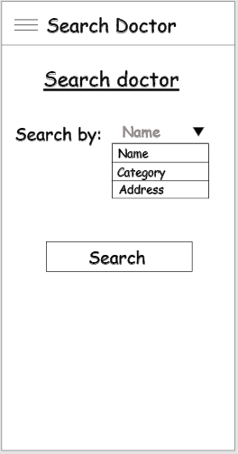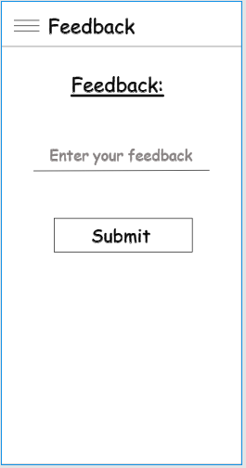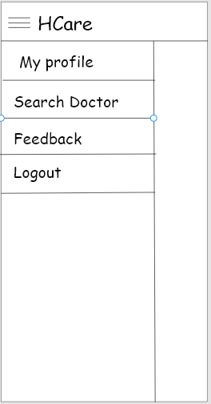

## Hardware Interfaces

Since the android application does not require any special hardware, there is no such hardware interface.

## Software Interfaces

1. Visual Studio Code

* Visual Studio Code is a source-code editor developed by Microsoft for Windows, Linux and macOS. It includes support for debugging and GitHub, syntax highlighting, intelligent code completion, snippets, and code refactoring. It is highly customizable, allowing users to change the theme, keyboard shortcuts, preferences, and install extensions that add additional functionality. The source code is free and open source.

1. XAMPP (Local Server)

* XAMPP is a free and open-source cross-platform web server solution stack package developed by Apache Friends, consisting mainly of the Apache HTTP Server, MariaDB database, and interpreters for scripts written in the PHP and Perl programming languages. Since most actual web server deployments use the same components as XAMPP, it makes transitioning from a local test server to a live server possible.

## Communications Interfaces

We will make use of Mail Chimp to mail the patients which uses HTTP to keep them updated about the application and to give them alert about their regular check-ups.

# System Features

This section gives an insight about the list of features that will be present in the system. The two applications will have different User Interfaces (i.e. Patients and Admins):

* 1. **Patient Registration**
     1. **Description and Priority**

Since this is the first step and authentication is an essential step to ensure security, the priority of this feature is high.

**4.1.2 Stimulus/Response Sequences**

On launching Patient’s application in android device the first UI will have an Authentication page, users can either Login if the account is already created or they can Sign Up. If a user selects the Sign Up option they will be redirected to the Registration page which will ask for Registration Details. After Successful registration users will be redirected to the login page.

* + 1. **Functional Requirements**
* The user (patient) will be asked to fill a Login form and it will be validated.
* If the user (patient) is a new one, he/she will be asked to register first and then login to the system using the credentials.
  1. **Patient Activities**

**4.2.1 Description and Priority**

After logging in the patient will be redirected to a page where the patient can enter their symptoms and the appropriate results based on the symptoms and further validation is generated which gives details about the disease that the user is suffering from. The user will have a menu bar having various options to select i.e.

* Search for disease module.
* Search for doctor module.
* Give feedback or logout. These are the main functionalities and thus, its priority is high.

**4.2.2 Stimulus/Response Sequences**

* In the search disease module, users will be asked for symptoms, then they will have multiple questions on various symptoms.
* In search for doctor module users can directly search for a doctor by entering their name, category or address.
* In the feedback module users can give feedback in the form of text.
* And by clicking the logout module they will be directly redirected to the login page.

**4.2.3 Functional Requirements**

* The symptoms selected by the user will be stored in the database and will be matched.
* The matched symptoms will generate the result.
* The doctors searched by the user will be fetched from the database and details will be given to the user.
* The feedback given by user will be stored for future.
  1. **Admin Login**
     1. **Description and Priority**

Since this is the first step and authentication of admin is essential step to ensure security, the priority of this feature is high.

* + 1. **Stimulus/Response Sequences**

On launching the application in android device the first UI will have an Authentication page, admin will have to Login first.

* + 1. **Functional Requirements**

The admin will be asked to enter the credentials and it will be validated for authentication purpose.

* 1. **Admin Activities**
     1. **Description and Priority**

After logging in the admin will be redirected to a page where the admin can see the details of the patients visiting the website. Admins will be provides a menu bar with some important set of activities that should be performed by the admin i.e.:

* Admins can add the verified doctors on the web application.
* Admins can add the diseases and their related symptoms.
* Admins can even keep a track of all the patients visiting the web application.

In short admin can monitor all the activities of the web application.

* + 1. **Stimulus/Response Sequences**
* In the add doctors module, admin can add the verified doctors by whom the data about different diseases and their symptoms are collected to the application.
* In the add disease module, admin can add the new symptoms related to an existing disease or can also add a new disease along with its symptoms.
* Admin also have module where admin can see the details of the patients who are visiting.

**4.3.3 Functional Requirements**

* The details of disease selected by the user and stored in the database will be displayed to the doctor
* The patient details will be fetched from the database and details will be made available to the doctor.

# Other Nonfunctional Requirements

## Performance Requirements

This system must remain in a consistent state and must be available at all times (in an emergency). Since all the work involved is related to data storage and data retrieval, there must be proper backup of data and data must be available all the time to access.

## 5.2 Security Requirements

All security parameters and goals of security which includes Confidentiality, Integrity and Availability (CIA) must be ensured.

Data needs to be highly confidential as any exploitation can lead to privacy concerns for patients.

## 5.3 Software Quality Attributes

1. Adaptability: This system can be adopted to accommodate more features easily.
2. Maintainability: Updates can easily be maintained and launched.
3. Efficiency: Easy and Simple.
4. Reliability: The data must be consistent and secure.